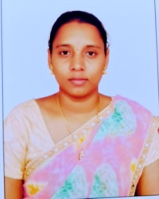
KANULLA BINDHU MADHAVI

Department: BasicSciences and Humanities
College: Seshadri Rao Gudlavalleru Engineering College
Mobile: 8106563012
E-Mail:kanullabindhu.m@gmail.com

RESIDENTIALADDRESS:
D.No: 2-98
Kummari Veedhi, Bhushanagulla,
Pedaparupudi Mandal

ACADEMIC QUALIFICATIONS: M.Sc.,B.Ed.
ACADEMIC REWARDS/ ACHIEVEMENTS:Nil PROFESSIONALEXPERIENCE:
Designation | Institution | Period
Degree Lecturer | A.N.R. College, Gudivada | 2021-24(oct-may)
Lecturer | Sri Jyothi Polytechnic College,Kalavapamula | Jun-sep(2025)
Asst.Prof. | Gudlavalleru EngineeringCollege,  Gudlavalleru | 22-09-2025
PROJECTSGUIDED:

PhD | Post Graduation | UnderGraduation
NIL | NIL | NIL
SPECIALIZATION: Mathematics

RESEARCHPAPERS/BOOKS:Nil
BOOKS PUBLISHED IN PUBLICATIONS: NIL RECENTPUBLICATIONS/CONFERENCES:

International/NationalJournals | International/NationalConferences
Nil | Nil

PapersPresentedconferences:NIL

LISTOFWORKSHOPSORGANIZED:NIL
LISTOFWORKSHOPS/SEMINARSATTENDED:01
CERTIFICATIONS: 01
INDUSTRIALTRAINING:NILGUESTLECTURESDELIVERED:NIL
MEMBERSHIPINPROFESSIONALBODIES:NIL CONSULTANCY ACTIVITIES: NIL
GRANTSFETCHED:NIL

